WEBFLOW4SLIDES:

TEORIA:

Limiti specifica Servlet:

- Api Servlet, manca scope conversazione (limiti session)

Vantaggi Spring WebFlow:

- Design conversazioni (flow)
- Indipendenza dalla specifica Servlet (può essere applicato a qualsiasi flusso UI)
- Design processi condivisibile a livello meno tecnico
- Si integra attraverso interfacce coi componenti Web (validator, converter etc.)
- Flow engine per i principali web frameworks
- Facilita Test unita

OGGETTI CONFIGURAZIONE:

ARCHITETTURA:
- FlowController
- FlowRegistry
- ViewTemplate e vincoli su viste
- FlowExecutor
- FlowRepository

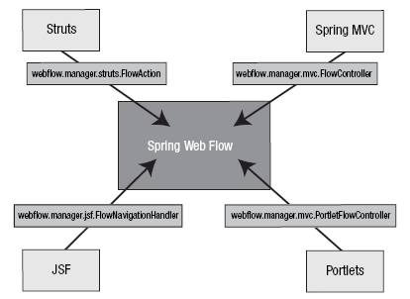
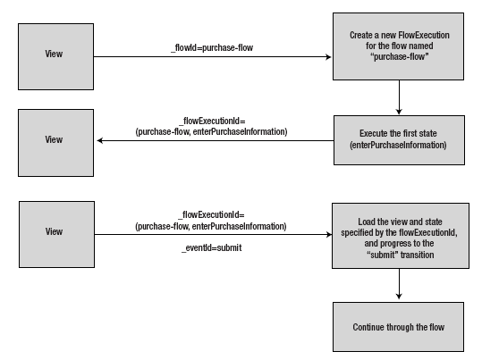

Flow:

A flow encapsulates a reusable sequence of steps that can execute in different contexts.

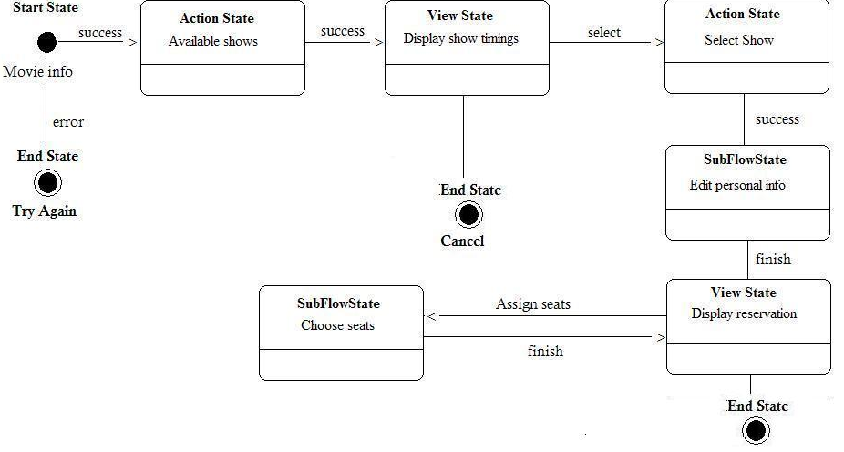

Definito attraverso un file xml gestito all’interno di web applications

Un flow consiste in:

Una sequenza di State

Gli state possono generare Events

Le cui transizioni conducono a delle View

DOMINIO SWF2

Transition:
(uno tra i ) Possibile reindirizzamenti conseguenza di un evento.
Simile al forward di struts.

Event:
Evento rilevato dall’applicazione che fa scattare una transition verso un altro state

Flow States:
View-state
Definizione di una vista per gestire interazione con utente (i/o)

Action-state
Stato che collega ad un punto di elaborazione (servizio.metodo)

Decision-state:
Stato che definisce un punto decisionale (se questa condizione e’ vera

SubFlow state
Stato che definisce una chiamata ad un altro flow

End State
Uno dei possibili stati finali del flow

Rappresentazione flows:

Flow (xml)
Every flow begins with the following root element:
<?xml version="1.0" encoding="UTF-8"?>
<flow xmlns="http://www.springframework.org/schema/webflow"
xmlns:xsi="http://www.w3.org/2001/XMLSchema-instance"
xsi:schemaLocation="http://www.springframework.org/schema/webflow
http://www.springframework.org/schema/webflow/spring-webflow-2.0.xsd">

</flow>

Tutti gli state sono definiti all’interno dell’elemento <flow>

view-state
Use the view-state element to define a step of the flow that renders a view:
<view-state id="enterBookingDetails" />

By convention, a view-state maps its id to a view template in the directory where the flow is located.
For example, the state above might render
/WEB-INF/hotels/booking/enterBookingDetails.xhtml
if the flow itself was located in the
/WEB-INF/hotels/booking directory.

transition
Use the transition element to handle events that occur within a state:
<view-state id="enterBookingDetails">
<transition on="submit" to="reviewBooking" />
</view-state>

Quale evento indirizza verso quale state
These transitions drive view navigations.

End-state
Use the end-state element to define a flow outcome:
<end-state id="bookingCancelled" />

When a flow transitions to a end-state it terminates and the outcome is returned.

Esempio completo view navigation logic using these elements:

<flow xmlns="http://www.springframework.org/schema/webflow"
xmlns:xsi="http://www.w3.org/2001/XMLSchema-instance"
xsi:schemaLocation="http://www.springframework.org/schema/webflow
http://www.springframework.org/schema/webflow/spring-webflow-2.0.xsd">

<view-state id="enterBookingDetails">
<transition on="submit" to="reviewBooking" />
</view-state>

<view-state id="reviewBooking">
<transition on="confirm" to="bookingConfirmed" />
<transition on="revise" to="enterBookingDetails" />
<transition on="cancel" to="bookingCancelled" />
</view-state>

<end-state id="bookingConfirmed" />

<end-state id="bookingCancelled" />

</flow>

<flow xmlns="http://www.springframework.org/schema/webflow"
xmlns:xsi="http://www.w3.org/2001/XMLSchema-instance"
xsi:schemaLocation="http://www.springframework.org/schema/webflow
http://www.springframework.org/schema/webflow/spring-webflow-2.0.xsd">

<view-state id="enterBookingDetails">
<transition on="submit" to="reviewBooking" />
</view-state>

<view-state id="reviewBooking">
<transition on="confirm" to="bookingConfirmed" />
<transition on="revise" to="enterBookingDetails" />
<transition on="cancel" to="bookingCancelled" />
</view-state>

<end-state id="bookingConfirmed" />

<end-state id="bookingCancelled" />

</flow>

Actions State:
Punti di ingresso per accesso ai business services.
E’ possibile definire dei collegamenti alle action in vari punti:
- On flow start
- On state entry
- On view render
- On transition execution
- On state exit
- On flow end

Evaluate (EL)
The action element you will use most often is the evaluate element.
Use the evaluate element to evaluate an expression at a point within your flow.
With this single tag you can invoke methods on Spring beans or any other flow variable.
For example:
<evaluate expression="entityManager.persist(booking)" />

Risultato Action
If the expression returns a value, that value can be saved in the flow's data model called flowScope:
<evaluate expression="bookingService.findHotels(searchCriteria)" result="flowScope.hotels" />

Conversione
If the expression returns a value that may need to be converted, specify the desired type using the result-typeattribute:
<evaluate expression="bookingService.findHotels(searchCriteria)" result="flowScope.hotels"
result-type="dataModel"/>

Flow con actions:
now review the sample booking flow with actions added:
<flow xmlns="http://www.springframework.org/schema/webflow"
xmlns:xsi="http://www.w3.org/2001/XMLSchema-instance"
xsi:schemaLocation="http://www.springframework.org/schema/webflow
http://www.springframework.org/schema/webflow/spring-webflow-2.0.xsd">

<input name="hotelId" />

<on-start>
<evaluate expression="bookingService.createBooking(hotelId, currentUser.name)"
result="flowScope.booking" />
</on-start>

<view-state id="enterBookingDetails">
<transition on="submit" to="reviewBooking" />
</view-state>

<view-state id="reviewBooking">
<transition on="confirm" to="bookingConfirmed" />
<transition on="revise" to="enterBookingDetails" />
<transition on="cancel" to="bookingCancelled" />
</view-state>

<end-state id="bookingConfirmed" />

<end-state id="bookingCancelled" />

</flow>

This flow now creates a Booking object in flow scope when it starts. The id of the hotel to book is obtained from a flow input attribute.

Tutorial: SWF Basic (Segue..)

SPRING WEBFLOW2 : HelloWorld

Obiettivo:
Configurazione di base che permette di ottenere una pagina di benvenuto come primo step di uno spring webflow.

Librerie:
Spring3, SpringWF2, Spring Mvc

Steps: Overview

1) Web.xml:
Abilitare la DispatcherServlet di Spring Mvc
Mapping degli url verso la Dispatcher

2) Dispatcher-servlet.xml:
Mapping
ViewResolver
Import del file di configurazione di Spring Web Flow

3) swf2-config.xml
File di configurazione del contesto di Spring WebFlow
Definizione di:
FlowController
FlowExecutor
FlowRegistry nel quale collocare i files dove sono definiti i flows

Web.xml

<servlet>
<servlet-name>dispatcher</servlet-name>
<servlet-class>
org.springframework.web.servlet.DispatcherServlet
</servlet-class>
</servlet>

<servlet-mapping>
<servlet-name>dispatcher</servlet-name>
<url-pattern>*.do</url-pattern>
</servlet-mapping>

Dispatcher-servlet.xml:
<!-- Maps flow requests from DispatcherServlet to flowController -->
<bean class="org.springframework.web.servlet.handler.SimpleUrlHandlerMapping">
<property name="mappings">
<value>
/myapp/myflow.do=flowController
</value>
</property>
<property name="alwaysUseFullPath" value="true"/>
</bean>

<!-- Maps a logical view name to a physical resource -->
<bean id="viewResolver" class="org.springframework.web.servlet.view.InternalResourceViewResolver">
<property name="prefix" value="/WEB-INF/views/"/>
<property name="suffix" value=".jsp"/>
</bean>

swf2-config.xml

<bean id="flowController" class="org.springframework.webflow.mvc.servlet.FlowController">
<property name="flowExecutor" ref="flowExecutor"/>
</bean>

<flow:flow-executor id="flowExecutor" flow-registry="flowRegistry"/>

<!-- This creates an XmlFlowRegistryFactory bean -->
<flow:flow-registry id="flowRegistry" flow-builder-services="flowBuilderServices">
<flow:flow-location path="/WEB-INF/flows/myflow.xml"/>
</flow:flow-registry>

<flow:flow-builder-services id="flowBuilderServices" view-factory-creator="viewFactoryCreator"/>

<bean id="viewFactoryCreator" class="org.springframework.webflow.mvc.builder.MvcViewFactoryCreator">
<property name="viewResolvers">
<list>
<ref bean="viewResolver"/>
</list>
</property>
</bean>

Collegamenti:

1. Index.jsp: url=myflow.do -> intercettato da SpringDispatcher *.do

2. Nei mappings (myapp/myflow -> indirizzato a FlowController

3. FlowController cerca nel registro un flow il cui name=myflow
Di default il nome del flow corrisponde a quello del file in cui è definito.

4. Carica il flow myflow.xml nel quale trova la definizione del processo.

Myflow.xml

<!-- By default, the first state is the start state. -->
<view-state id="helloFlow" view="HelloWorld" />

Indirizza verso l’outcome “HelloWorld”

Che viene processato dal viewresolver che gli aggiunge

WEB-INF/views come prefisso e .jsp come suffisso.

Navigazione

Aggiungiamo al flusso myflow altri view-state:

Flow 100-NAVIGATION: TUTORIAL

Come generare eventi per transitions

The point of the two links is to give the user a way to generate submitRegistration andcancelRegistration events.

We saw in the flow definition that these two events trigger state transitions. Of special importance is the URL for each of these links.

Notice that by using ${flowExecutionUrl}, we're still pointing the user at the same /account/register.do servlet path.

That's because we're still working within the register flow. The ${flowExecutionUrl} URL includes HTTP PARAMETERS:

1) execution whose value is a key that SWF uses for flow-tracking purposes.

2) In addition we add an _eventId parameter that we use to drive state transitions.
The event IDs are what we're referencing when we define transitions in the flow definition file.

FLOW 200-ACTIONS:

III. Action
There are 3 ways to implement the Action logic.

1. invoking a POJO action.

<evaluate expression="pojoAction.method(flowRequestContext)" />

public class PojoAction {
public String method(RequestContext context) {
...
}
}

2. invoking a custom Action implementation.

<evaluate expression="customAction" />

public class CustomAction implements Action {
public Event execute(RequestContext context) {
...
}
}

3. invoking a MultiAction implementation.

<evaluate expression="multiAction.actionMethod1" />

public class CustomMultiAction extends MultiAction {
public Event actionMethod1(RequestContext context) {
...
}

public Event actionMethod2(RequestContext context) {
...
}

}

FLOW 300-MAPPING INPUT E OUTPUT:

